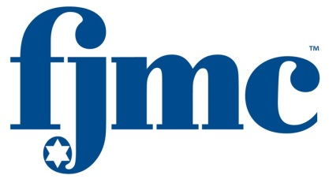

**Tell your family you’re doing serious things for them and the Jewish Community. Tell them:**

* “Involvement in our Men's Club helps us be better role models for our children.”
* “Being active in our men’s club serves the needs of our congregation and leads to greater involvement in our synagogue.”
* “Our club’s programs, resources, and initiatives enable us to address the critical issues that we, as men, have to tackle in our lives.”

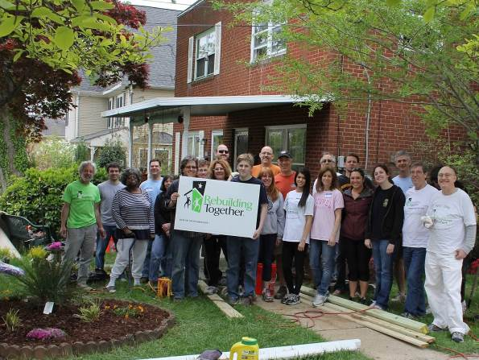

“We help the community.”

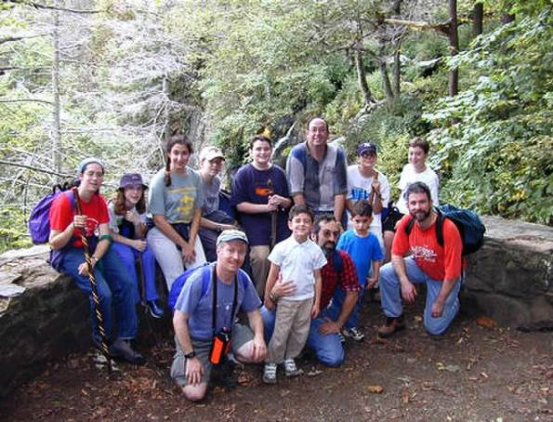

“We connect with friends, family, and nature.”

**About our club**

As a club affiliated with the Federation of Jewish Men’s Clubs (FJMC), a group of over 250 clubs with over 20,000 members in Conservative/Masorti synagogues around the world, we fulfill the needs of men like you. We come together to get involved in Jewish living and help address family and community concerns, in a spirit of camaraderie and fun.

***Together, we sponsor blood drives; visit the sick; tutor children; build sukkot; and engage in serious discussions about being a man in an increasingly egalitarian world. We cultivate volunteers and train leaders; find jobs for those in need; sponsor parent-child activities and athletic events; help families learn to make Shabbat, read Hebrew, commemorate Yom HaShoah, and put on tefillin. We help raise needed funds for our synagogue, our community, and the global Conservative/Masorti Movement.***

**We have a place for you**

All these activities were started by men like you – ***some activities we do regularly; others are available for you to innovate and lead.*** We’re open to men of all ages, from those with young families to those whose families are fully grown, and everything in between. Come join us and let your unique passion be a catalyst for change.

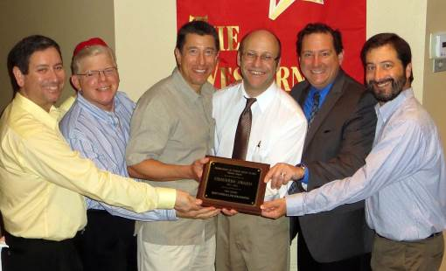



## *Come Join*

## *Our Men’s Club!*

*Here’s how to get in touch with our club:*

*© 2013 by FJMC. For additional copies of this brochure, write* [*International@FJMC.org*](mailto:International@FJMC.org)*. Permission granted to your affiliated FJMC club to tailor and print for your own club. Version: 7/11/13.*

**www.fjmc.org**

***“Our club follows the FJMC mission to involve Jewish Men in Jewish Life.”***

**“We do this through Leadership”**

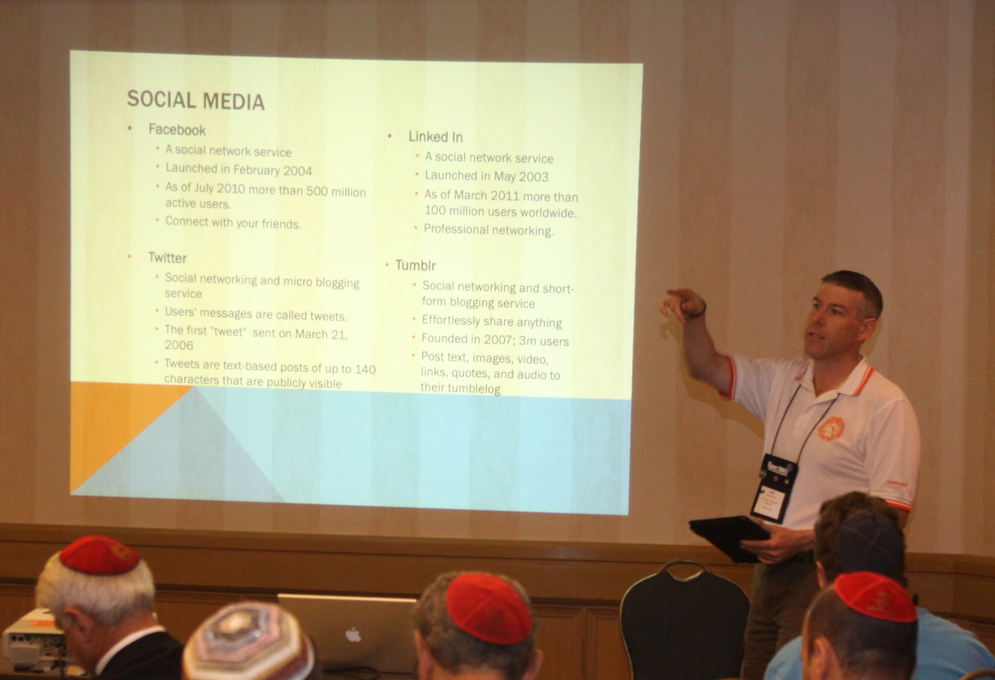  
“We enjoy mentoring leaders in our club, and we take advantage of FJMC leadership training at retreats and Convention”

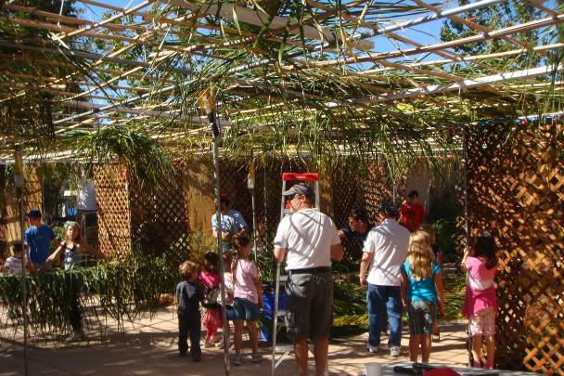

“We lead synagogue events for the whole family.”

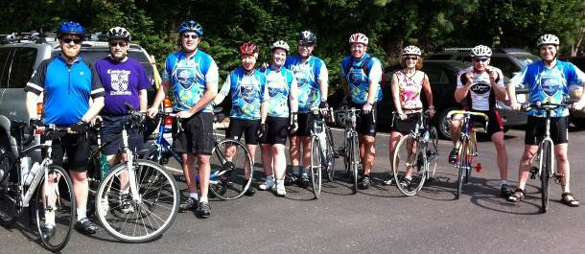

“We run fun wellness initiatives.”

**“We do this through Innovation”**

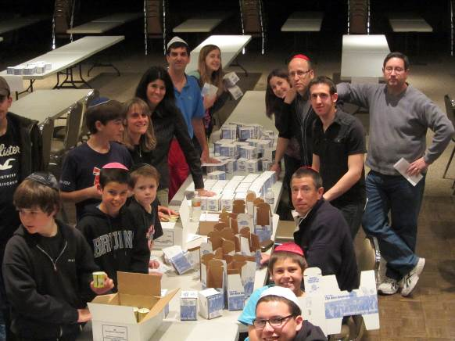

“We use innovative FJMC-developed programming that better connects people of all ages to the Jewish Community.”

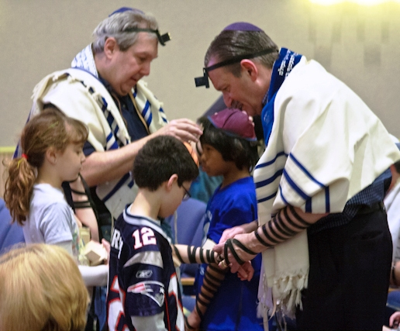

“With other clubs worldwide, we lead   
Jewish observance initiatives for   
thousands each year.”

**“We do this through Community”**

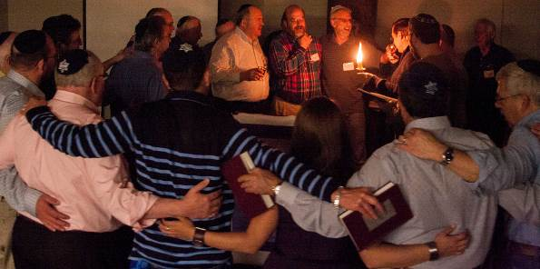

“We form meaningful, long-lasting relationships based on camaraderie, common interests and core values.”

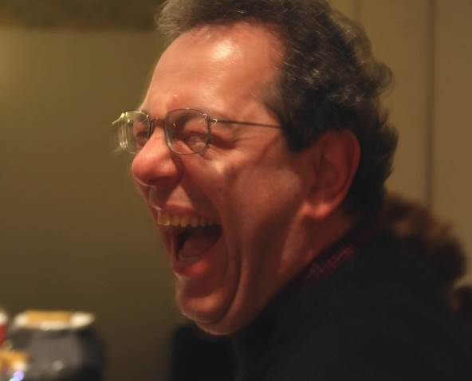

“You don’t have to tell your family if you don’t want to. Just between us, you’re going to make some very strong friendships, and you’re going to have a lot of fun!”