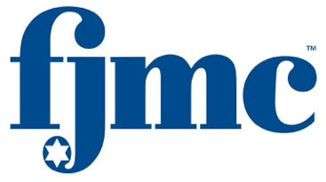

Dear  Friends,

[Insert Honoree] has been selected by the FJMC [InsertRegion] Region to receive the 2025 Ma’asim Tovim (Doer of Good Deeds) honor. This recognition will be presented to [honoree First Name] by the region during the FJMC Biennial Convention, scheduled from July 3 to July 6, 2025, at the Sheraton Grand Chicago Riverwalk in downtown Chicago.

This is the highest honor from FJMC, recognizing significant contributions to one's club, synagogue, and the Jewish community. [honoree First Name] joins a group of dedicated volunteers whose efforts have improved our lives and the world.

The biography of [honoree First Name], along with a summary of his accomplishments, will be published in the 2025 FJMC Convention Journal. The journal serves to acknowledge [honoree First Name] and other volunteers within the Federation of Jewish Men’s Clubs, its affiliated regions, and member clubs.

Honor [honoree First Name] by purchasing an ad or donating to the 2025 FJMC Convention Journal. Tribute prices range from $54 for a listing to $5,000 for a Platinum Sponsorship. Details are available on www.fjmc.org and the attached sheet. Proceeds support FJMC's new initiatives, regional and essential services for member clubs.

We have had the pleasure of knowing [honoree First Name] for many years, and he is truly deserving of this recognition. We invite you to join us in honoring [honoree First Name] and his dedication to volunteerism by purchasing a tribute in his name. Tributes can be submitted via email at journal@fjmc.org.

Thank you in advance for your generous support.

Respectfully yours in Brotherhood,

[Joe Solicitor]

[InsertRegion] Region Ad Chairman

Steve Lessman

FJMC Ma’asim Tovim Awards Chair

Mark Givarz and Jay Steinmetz

FJMC Convention 2025 Chair and Co-Chair