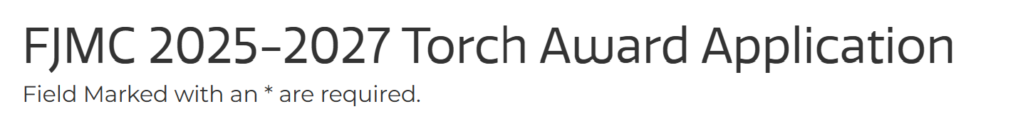
Word Document to help prepare to fill out FJMC 2027 Torch Award Submission
The following document can be used to help prepare information prior to logging onto FJMC website to enter information for Torch Awards. You can not just send this document. And remember all the work must be done in one session. Submission has three sections as shown below. Each section has an unique page that needs to be filled in before proceeding to the next page.
PAGE ONE
Club Name - choose from region dropdown, and club list will appear. Select from club list. ONLY If the club name is not listed in the region dropdown choose CLUB NOT LISTED at end and enter region and club in next box.
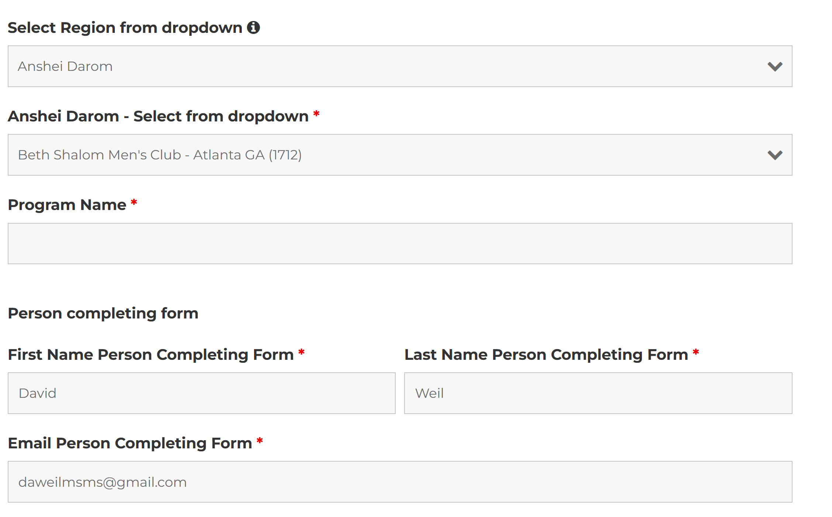
Program Name:

After logging onto the FJMC website the form automatically adds name/email of person completing the submission
Club President at time of convention if know at this time
First Name Pres. at time of Convention: Last Name Pres. at time of Convention:

Current Club President
First Name of current President * Last Name of current President *

Entry Category. The Chairmen reserve the right to reclassify your submission category where applicable.
Category Select the category then click NEXT to go to next page
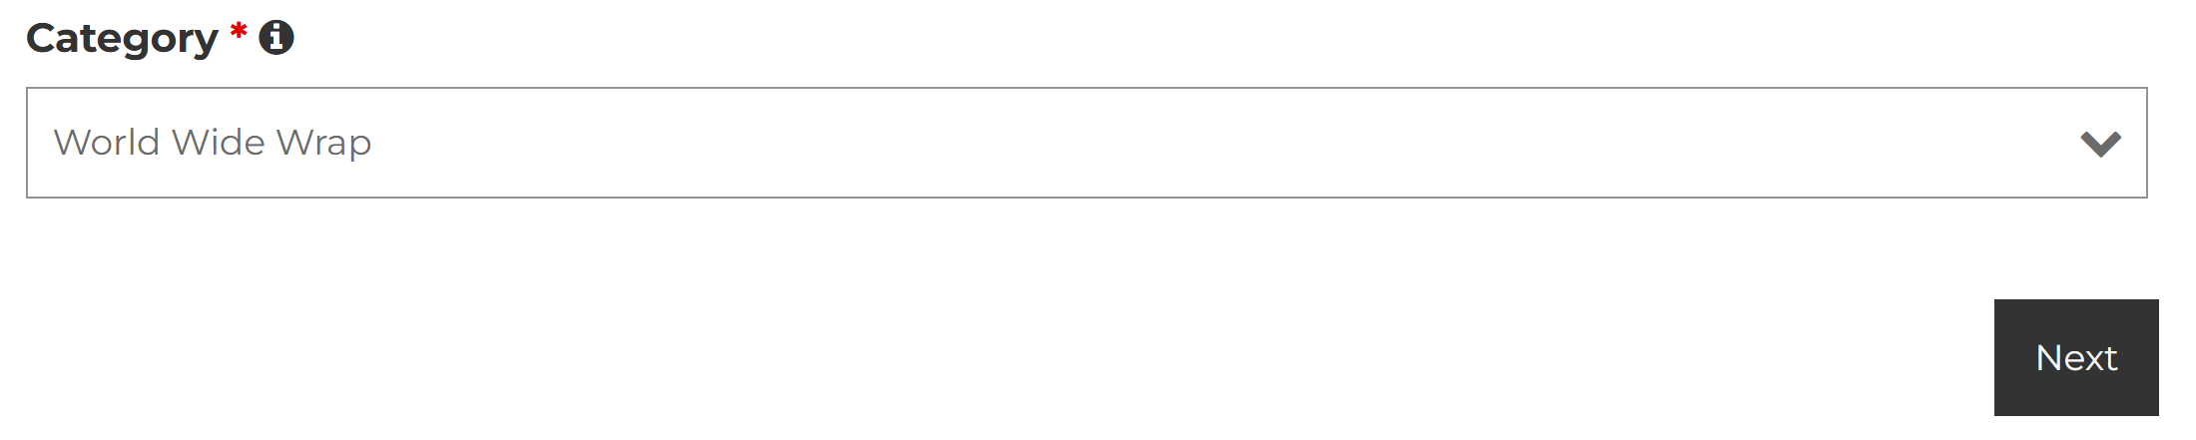
Program Details Page (2)
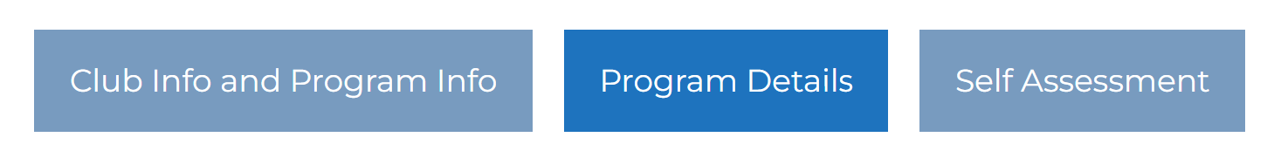
Program Overview Section:
Summary information (2-3 sentences). Explain what your program is. This short description will be included in the list of award winners after the International Convention. Example for summary box: "The overall goal of the program is to encourage the Congregational community to become more involved in fulfilling the mitzvah of Tefillin. The program consisted of six distinct components. They were: 1) Build a Pair, 2) Tefillin Class, 3) Shacharit Service, 4) Musical Wrapping, 5) Brunch Wraps, and 6) Sofer Talks."

Detailed Program:
Describe your program (you can 'cut & paste' from a Word document into this field). Attach supporting documentation, so other clubs can replicate it, in the field immediately below.

Attachments: Detailed Program Document: Click on “Select Files” to add do files.
Provide one or more referenced documents that help describe the program. PDF document uploads are preferred, but documents in Microsoft Word, Excel, or PowerPoint can be read by the judges and distributed. Please limit your upload to these formats. The font for all documents should be in standard fonts such as Calibri, Arial or Times Roman. 3 MB Maximum

Advanced Programming: Select Files to Upload:
Describe the timeline with all the tasks to make the program work. Timeline will explain: How long did it take, key events, how did your members participate. From the Torch Award Program Overview Page, find the "Torch Award Program Schedule Template" link (Excel spreadsheet) in the right-hand sidebar of that page and click it to download to your computer through your browser.

Marketing: Select Files
Attach brochure, E-Mail Blasts, Announcements, Public relation releases, Temple Mailers, Postcards, etc. PDF document uploads are preferred, but documents in Microsoft Word or PowerPoint can be read by the judges and distributed. Please limit your upload to these formats. The font for all documents should be in standard fonts such as Calibri, Arial or Times Roman.

Photos: Select Files
Guidelines for attachments - It is preferable that photos, scans or handouts, and the like be kept moderate in dimension and limited in size. If possible, please reduce the electronic size of images inserted in documentation. Maximum size 5 MB per file. Photos can be in jpg, png, tiff, or heic format.

Video: Insert YouTube Link
According to the instructions, upload your video to YouTube and enter the YouTube link for video submission here.
Click NEXT…
Self Assessment Page
IMPACT:
Impact: Briefly tell us about your submission's impact on your club, synagogue and community. Was the program a success? How was it received? What is its value in club building - number of club members participating versus club size and synagogue / congregation family units.

FJMC:
Briefly explain how the program supports the FJMC mission of Involving Jewish Men in Jewish Life and how the program relates to and/or supports one or more elements of the FJMC tagline: Leadership, Innovation, Community.

Additional Input:
Is there any additional input you would like to share with our fellow FJMC clubs?

After all the material and areas are filled up please hit the Submit Button…

